# DRAWING TOOL

### A MINI PROJECT REPORT

#### Submitted by

#### Group/Team No: G-21/T-22

**NIMIT GULATI,2310991915**

**NITASHA,2310991917**

**NITPREET SINGH,2310991918A**

#### in partial fulfillment for the award of the degree of

## BACHELEOR OF ENGINEERING

***in***

COMPUTER SCIENCE & ENGINEERING



**CHITKARA UNIVERSITY**

**CHANDIGARH-PATIALA NATIONAL HIGHWAY**

**RAJPURA (PATIALA) PUNJAB-140401 (INDIA)**

December,2023

##### **ABSTRACT**

A drawing tool is a software or physical instrument that allows users to create visual representations. on various mediums . These tools often provide a range of features , such as selecting colors , brush types , and drawing shapes , to enable users to express their creativity and convey ideas through illustrations and artwork. They are used in various domains, from artistic endeavors to technical design and illustration, making them a versatile means of visual expression.

A drawing tool, whether in the form of software or a physical instrument, serves as a dynamic gateway for users to manifest their creative vision and convey ideas through the captivating realm of visual representation. These tools encompass a spectrum of functions and features, facilitating the transformation of blank canvases into vibrant expressions of artistry.At their core, drawing tools offer users the ability to manipulate an array of elements, including color, brush types, and drawing shapes. This rich palette of choices empowers individuals to craft their creative narratives with precision, from broad, sweeping brushstrokes to the fine, intricate details that breathe life into their work.

The applications of drawing tools are as diverse as the imaginations of their users. In the realm of artistic pursuits, they are the quintessential companions of painters, illustrators, and designers, enabling them to translate their innermost thoughts into visual masterpieces. Whether capturing the ethereal beauty of a natural landscape or giving form to abstract concepts, these tools become the conduits of artistic expression.

However, the utility of drawing tools extends far beyond the canvas of traditional art. In the world of technical design and illustration, they are indispensable instruments. Engineers and architects employ them to draft precise blueprints, infusing creativity into the practicality of their work. Technical illustrators use these tools to elucidate complex ideas, simplifying intricate concepts into comprehensible visuals.

Drawing tools have become essential in the modern digital landscape, where creativity knows no bounds. With their digital counterparts, users can seamlessly transition between traditional and cutting-edge mediums, unleashing their artistic potential across platforms. In an era characterized by digitization, these tools embody the fusion of artistry and technology, opening a world of infinite possibilities.

In conclusion, the beauty of drawing tools lies in their adaptability, transcending the boundaries of artistic expression and finding relevance in myriad domains. They are the conduits that transform

blank canvas into a captivating narrative, where colors, shapes, and strokes become the building blocks

of visual expression. From art to science, they continue to serve as invaluable means of communication and creativity in the diverse landscapes of human expression Drawing tools, whether in the form of software applications or physical instruments, serve as versatile mediums for individuals to articulate their creativity visually. These tools encompass an extensive range of features, empowering users to create expressive artwork and convey intricate ideas through illustrations. Offering a plethora of options such as color selection, diverse brush types, and the ability to create various shapes, drawing tools become the conduit through which imaginative visions materialize into tangible forms.

At their essence, these tools grant users the ability to manipulate a diverse array of elements. This rich palette of choices enables individuals to craft their narratives with precision, capturing the essence of their ideas through broad, sweeping strokes or intricate, nuanced details that breathe life into their creations.

The applications of drawing tools are as varied as the creative minds that employ them. In the. realm of artistic endeavors, they are indispensable companions to painters, illustrators, and designers, facilitating the translation of inner thoughts and emotions into captivating visual masterpieces. Whether depicting the serene beauty of a natural landscape or encapsulating abstract concepts in tangible forms, drawing tools serve as vessels of artistic expression, enabling creators to share their perspectives with the world.

However, the utility of drawing tools extends beyond the realm of traditional art. In technical design and illustration, these tools hold immense significance. Engineers and architects utilize them to draft precise blueprints, infusing creativity into the practical aspects of their work. Technical illustrators leverage these tools to simplify complex ideas, creating visuals that elucidate intricate concepts for better understanding.

Moreover, drawing tools have seamlessly transitioned into the digital landscape, where they play an integral role in unleashing creative potential across platforms. Their digital counterparts enable users to effortlessly navigate between traditional and contemporary mediums, offering a boundless canvas for artistic exploration. In an era characterized by digitization, these tools embody the fusion of artistry and technology, opening up a realm of endless possibilities for creators worldwide.

In essence, the allure of drawing tools lies in their adaptability, transcending boundaries of artistic expression to find relevance in diverse domains. They serve as conduits that transform blank canvases into captivating narratives, where colors, shapes, and strokes converge to form the very essence of visual expression.

**TABLE OF CONTENTS**

|  |  |  |
| --- | --- | --- |
| **Sr.no** | **Section** | **Page no** |
| 1 | Introduction | 5 |
| 2 | Problem Statement | 7 |
| 3 | Technical Details | 8 |
| 4 | Key Features | 11 |
| 5 | Project Advantages | 13 |
| 6 | Bonus Feature | 14 |
| 7 | Results | 17 |
| 8 | Conclusion | 20 |
| 9 | References | 21 |

##### **INTRODUCTION**

BLENDING PALETTE - Your ultimate drawing tool for creating blending…..Welcome to the future of digital creativity! Our innovative drawing tool blending palette redefines artistic expression, allowing you to effortlessly create shapes and drawings with a variety of pen styles and shapes. This seamless fusion of traditional artistry and technology opens up a world of limitless possibilities. Whether you're a budding artist, an experienced illustrator, or simply a creative spirit, this tool is your ultimate companion. Bid farewell to the constraints of traditional supplies and embrace a realm where your imagination knows no bounds. Discover how every stroke and shape can become a masterpiece in this transformative digital art experience. No matter your skill level, from novice artists to seasoned illustrators, the Blending Palette empowers you to craft your vision with unparalleled ease. It seamlessly combines a multitude of pen styles and shapes, enabling you to effortlessly bring your imagination to life on the digital canvas. The blending palette invites you to bid farewell to the limitations of conventional art supplies. Embrace a universe where your creative potential knows no bounds. It's a realm where every stroke and shape you create has the potential to evolve into a breathtaking masterpiece. Explore a cornucopia of possibilities, from bold, vibrant strokes to delicate, intricate details. This tool harmoniously marries the tactile sensation of traditional artistry with the boundless capabilities of modern technology. Your creativity becomes a limitless force, ready to transmute your ideas into digital wonders. In this transformative digital art experience, you are no longer confined by the constraints of physical mediums. 1

The Blending Palette is your ultimate companion in your artistic journey, ready to unlock your potential, fuel your inspiration, and redefine the way you create. Welcome to the future of digital creativity, where every stroke becomes a story and every shape an expression of your soul. One of the most liberating aspects of the Blending Palette is its capacity to liberate you from the constraints of traditional art supplies. Bid farewell to the world of limited colors, erasers, and fixed canvas sizes. Instead, embrace a universe where your creative potential knows no bounds. Every stroke, every shape, and every shade becomes a realm of possibilities, waiting to evolve into breathtaking masterpieces. Within the Blending Palette, you'll discover a cornucopia of artistic possibilities. From bold and vibrant strokes that exude energy and passion to delicate and intricate details that allow you to express the nuances of your imagination, this tool is your key to a world of artistic exploration. It harmoniously marries the tactile sensations of traditional artistry with the boundless capabilities of modern technology, creating a synergy that is greater than the sum of its parts. Your creativity transforms into an unbounded force, ready to transmute your ideas into digital wonders. As you embark on your transformative digital art journey with the Blending Palette, you'll notice that your creativity is no longer confined by the limitations of physical mediums. This tool becomes your trusted companion, unlocking your artistic potential, fueling your inspiration, and redefining the way you create. You're invited to immerse yourself in the future of digital creativity, where every stroke becomes a story, and every shape is a canvas for your soul's expression. With the Blending Palette, you're not just drawing; you're crafting the future of art itself. the Blending Palette, a revolutionary digital tool that redefines the landscape of artistic expression, marrying the fluidity of traditional artistry with the boundless potential of modern technology. In a world where creativity knows no bounds, this innovative tool transcends the limitations of conventional art supplies, offering a seamless fusion of versatility and creative freedom. Whether you're a novice exploring the depths of artistic expression or an experienced illustrator seeking new horizons, the Blending Palette invites you to embark on a transformative journey where every stroke, shape, and shade is a canvas for your imagination.

Problem Statement

The problems we faced while making the project were:

* Code Management: The Blending Palette Drawing Tool encounters difficulties in maintaining an organized and efficient codebase, leading to challenges in version control, and code consistency.
* Scalability and Performance:The Blending Palette Drawing Tool faces performance bottlenecks and scalability limitations, hindering its ability to handle increased user activity and deliver optimal performance across various devices and usage scenarios.
* Documentation Challenges:The Blending Palette Drawing Tool lacks comprehensive and accessible documentation, impeding user understanding, onboarding, and collaboration among contributors, resulting in inefficiencies and potential errors.
* Collaboration:The Blending Palette Drawing Tool struggles to foster effective collaboration among its development teams, hindering innovation, knowledge sharing, and collective problem-solving, leading to suboptimal outcomes.
* User Experience and Feedback:The Blending Palette Drawing Tool faces challenges in capturing user feedback and translating it into meaningful enhancements, resulting in a less-than-optimal user experience and potential disengagement from the user base.
* Knowledge Silos: The Blending Palette Drawing Tool suffers from siloed information and expertise within the organization, leading to fragmented knowledge, duplicated efforts, and reduced synergy among teams.
* Resource Allocation and Project Planning:The Blending Palette Drawing Tool encounters issues in effectively allocating resources and planning projects, resulting in missed deadlines, overallocation or underutilization of resources, and project delays.
* Technology Mismatch:The Blending Palette Drawing Tool experiences challenges in integrating different technologies cohesively, causing compatibility issues, increased maintenance efforts, and limiting the tool's overall functionality and usability.

Technical Details

This Html document defines the structure of a web page for a drawing tool centered around a canvas element. The head section includes metadata such as the character set, viewport configuration, and the title "Blending Palette." It also references external resources, namely a stylesheet ("style.css") for styling and a script ("script.js") for additional functionality, set to load asynchronously.

The body of the page contains a canvas element with the ID "canvas," serving as the primary drawing area. The navigation section ("nav") encompasses various color options represented as div elements with class "clr" and data attributes specifying the color values. Additionally, there are buttons for clearing the canvas, saving the drawing, activating an eraser, adding text, and undoing or redoing actions. The "brushType" select element allows users to choose between different drawing tools, and an input type color and range are provided for selecting color and adjusting brush size, respectively.

Furthermore, there's an emoji div displaying an image ("Paint.png"), and a container with a button linking to another page ("backupfp.html"). The footer section includes buttons for drawing shapes (circle, rectangle, triangle, square) with corresponding input elements for adjusting their sizes. Overall, this HTML document establishes the foundation for a feature-rich drawing tool with diverse options for color, brushes, shapes, and other functionalities.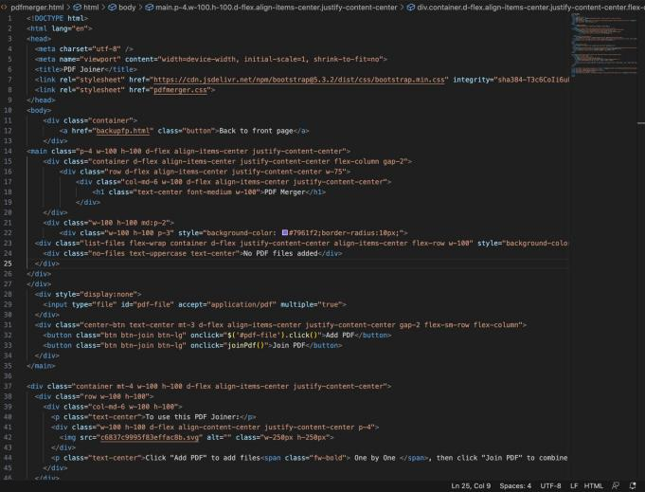

The CSS file styles the user interface elements, providing a visually appealing design with responsive behavior. It includes color selection options and style changes for buttons and shapes. Your CSS code appears to be well-structured and designed to style the HTML elements for your webpage. Additional styling includes specific designs for buttons like "text" and "shape," each with distinct background colors and hover effects. The "save" button has a unique background color as well. Input elements, such as the color picker and range input, have defined widths and heights. The footer has a fixed position at the bottom, with similar gradient background and border styles as the navigation bar. Selectors for undo and redo buttons are provided, although the associated HTML elements are not present. The stylesheet also includes styles for the "emoji" class, setting the font size and padding. Lastly, the "body" selector within the "undo" and "redo" sections appears to be a mistake, as it doesn't follow the correct syntax, and these sections are included within the curly braces of the button:hover property. Overall, the stylesheet is designed to create a visually appealing and functional interface for a drawing tool with a variety of features.

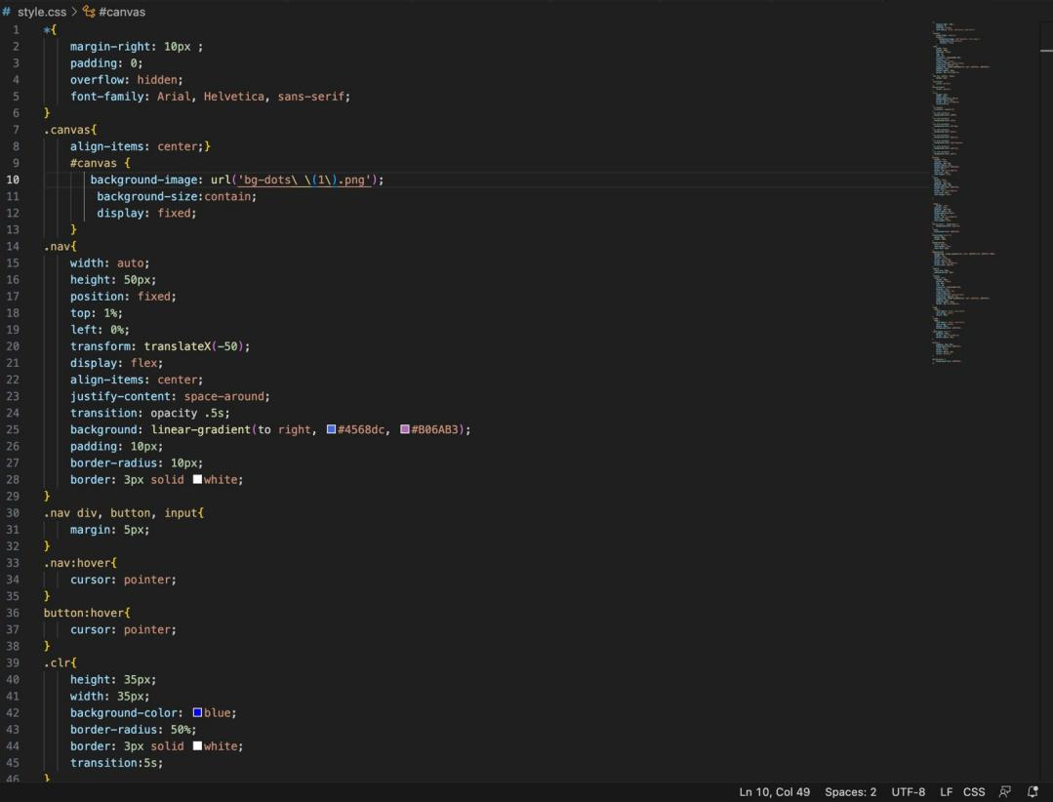

The JavaScript code handles user interactions and canvas drawing operations. It tracks the selected color, line width, and shape, allowing users to draw and add shapes to the canvas. It also supports actions like clearing the canvas and saving the artwork as an image. There's even an undo feature that can be extended for further functionality.It appears that you've provided a JavaScript code that interacts with an HTML canvas and various UI elements.

This JavaScript code orchestrates the functionality of a drawing tool implemented in a web page. The script retrieves the canvas element and sets its dimensions to match the window size. It establishes event listeners for various user interactions, such as changing colors, adjusting line width, and handling mouse movements for drawing on the canvas. Additionally, the script manages functionalities like clearing the canvas, saving the drawing as an image, and enabling an eraser.

Overall, this JavaScript code provides a comprehensive set of features for a drawing tool, combining color selection, line width adjustment, shape drawing, and the ability to undo and redo actions.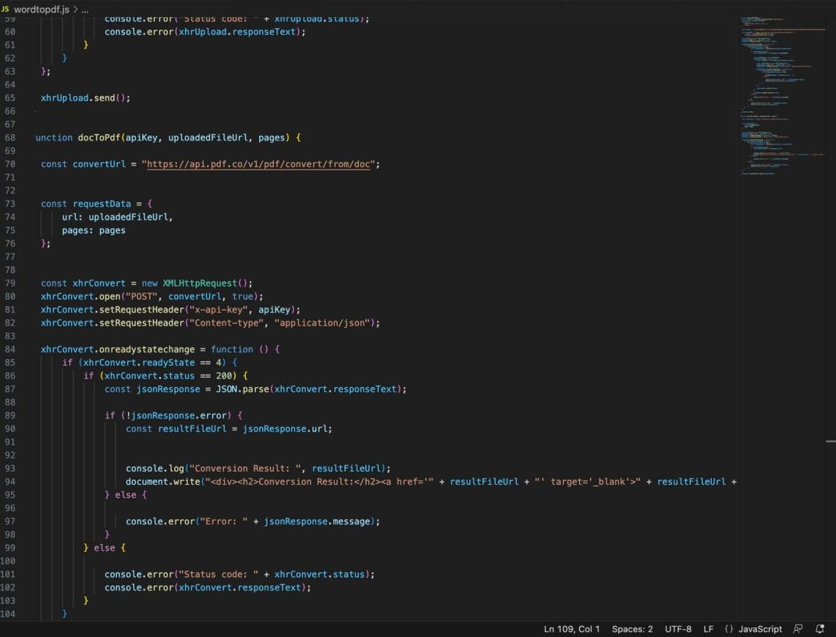

Key Features

Here are the list of key features :-

* **Canvas Drawing**: Users can create drawings on an HTML canvas with various line thicknesses and colors, making it suitable for both artistic and practical applications.Canvas Drawing allows users to express their creativity and practical needs on an HTML canvas. With options for selecting line thicknesses and colors, it's a versatile tool suitable for both artistic endeavors and practical tasks, making it a valuable addition to web applications and interactive platforms.
* **Color Palette**: A color palette allows users to select their preferred drawing color from a range of options, including a custom color picker.A Color Palette empowers users to choose their ideal drawing color from a diverse array of options, from pre-defined choices to custom selections using a color picker. This feature enhances artistic freedom and enables precise color selection for a wide range of creative and practical applications.
* **Brush Shapes**: Users can choose from different brush shapes, such as pencil, brush, and spray paint, enhancing creativity and versatility.Brush Shapes offer users the freedom to select from a variety of brush styles, including pencil, brush, and spray paint. This feature not only fuels artistic creativity but also extends the tool's versatility, making it suitable for diverse digital art and design applications.
* **Shape Drawing**: The tool supports drawing basic shapes like circles, rectangles, triangles, and squares, with adjustable sizes and colors.Shape Drawing functionality empowers users to create basic geometric shapes, including circles, rectangles, triangles, and squares. These shapes are customizable in terms of size and color, offering versatility for both artistic expression and practical design tasks within the tool.
* **Eraser**: An eraser function lets users easily remove unwanted strokes.The Eraser function provides users with a simple yet effective way to remove undesired strokes from their drawings. Acting like a digital eraser, it allows for precise editing and correction, enhancing the overall user experience and the quality of their digital creations.
* **Text Addition**: Users can add text to their drawings, facilitating annotations and labeling.Text Addition empowers users to include text within their drawings, facilitating annotations, labeling, and creative expression.
* **Undo/Redo**: The undo and redo buttons enable users to correct mistakes or revisit previous changes.The Undo and Redo buttons offer users the ability to effortlessly rectify errors or revisit prior modifications within their drawings. This valuable feature enhances user control and efficiency, ensuring that creative endeavors are a seamless and frustration-free experience.
* **Saving**: Users can save their drawings as PNG images for later use or sharing.The Saving feature allows users to preserve their creations by saving them as PNG images. This functionality ensures that their artwork or annotations can be stored for later use, shared with others, or integrated into various projects, contributing to the versatility and usefulness of the tool.
* **Navigation**: The user-friendly interface includes a navigation bar with clear buttons for various actions, making it accessible and intuitive.A user-friendly navigation bar provides a clear and accessible interface. It features intuitive buttons for actions such as drawing, shape creation, saving, undo/redo, erasing, and more. This thoughtful design ensures an easy and efficient user experience, enhancing the tool's usability for a wide range of tasks.
* **Customization**: Users can customize line thickness and background color, enhancing the personalization of their drawings.The tool's Customization options allow users to tailor their experience by adjusting line thickness and background color. This level of personalization empowers users to create drawings that truly reflect their unique style and preferences, fostering a more individualized and engaging creative process.
* Responsive Design: The tool is designed to work across different screen sizes and devices.The tool's Responsive Design ensures it functions seamlessly on various screen sizes and devices, from desktop computers to mobile devices.
* Streamlined Workflow: Users can seamlessly transition from drawing or creating visual content to converting and editing text-based documents without switching between multiple applications.

**PROJECT ADVANTAGES**

* Efficiency: Having multiple functionalities in a single tool saves time and effort by eliminating the need to use separate software for different tasks. Users can easily convert drawings or sketches into editable Word documents without leaving the drawing platform.
* Enhanced Collaboration: With integrated PDF merging capabilities, users can combine multiple PDFs or drawings into a single document, simplifying collaboration and sharing of comprehensive files.
* Versatility: Providing the ability to convert between different file formats—such as from PDF to Word or vice versa—enhances the tool's versatility, catering to various user needs for document editing and sharing.
* Cost-Efficiency: Instead of purchasing separate software for drawing, document conversion, merging, and PDF-to-document conversion, a blended tool offers a cost-effective solution by combining these features into one platform.
* User-Friendly Interface: A well-designed interface that integrates these functionalities seamlessly can provide an intuitive user experience, making it easier for individuals to navigate and utilize the different tools effectively.
* Increased Productivity: Users can work more efficiently by directly converting sketches, drawings, or PDF files into editable documents, saving time spent on manual data entry or recreating content.
* Accessibility and Convenience: Having all these features in one tool ensures accessibility and convenience for users who may need to perform various tasks without switching between multiple applications or services.

Bonus Feature(optional)

The Bonus Features of our website are:

* OCR (Optical Character Recognition): Integrate OCR technology to recognize text within images or scanned documents, enabling users to extract and edit text from images or scanned files.. By employing sophisticated algorithms, OCR accurately identifies and converts text within images, allowing users to seamlessly extract and edit textual content embedded in visuals. This capability revolutionizes workflows, as users can effortlessly manipulate and incorporate extracted text into their projects. Moreover, OCR significantly boosts accessibility by providing the means to transform non-editable image-based content into editable text, fostering greater efficiency and enabling a wider range of creative and professional applications within the drawing tool's framework.
* Cloud Integration: Allow users to seamlessly store, access, and synchronize their drawings and documents across multiple devices or cloud storage platforms like Google Drive, Dropbox, or OneDrive.This functionality empowers users to work flexibly, ensuring their projects are readily accessible regardless of location or device. By seamlessly syncing data between the drawing tool and preferred cloud services, users enjoy a cohesive experience, enabling smooth transitions between devices while safeguarding their work. This integration streamlines collaboration, boosts productivity, and enhances accessibility, fostering a user-friendly environment conducive to efficient creativity and document
* Annotation and Markup Tools: Offer a variety of annotation features such as highlighting, commenting, and drawing tools for users to mark up and annotate their documents or drawings easily .These tools encompass an extensive range of functionalities, including highlighting, commenting, and drawing options, enabling users to annotate and enrich their creations intuitively. Through intuitive and user-friendly interfaces, individuals can seamlessly add comments, draw shapes, underline important sections, highlight text, and incorporate various annotations to clarify ideas or provide feedback.
* Templates and Presets: Provide a library of templates and presets for various document types or drawing styles to assist users in starting their projects quickly.This extensive repository offers a.. diverse collection of pre-designed templates tailored for various document types or drawing styles. These ready-to-use templates serve as starting points, aiding users in swiftly commencing their projects without starting from scratch. Whether for specific document formats, design themes, or drawing structures, these presets streamline the creative process by offering frameworks that users can easily customize to their needs. By facilitating quick project kickoffs, the tool optimizes productivity and encourages creativity, catering to diverse user preferences and requirements.
* Collaboration Tools: Enable real-time collaboration features, allowing multiple users to work on the same document or drawing simultaneously, with chat or comment functionalities for communication. This feature creates an environment where users can work simultaneously, fostering seamless teamwork and collective creativity. Alongside simultaneous editing, chat functionalities and comment systems are embedded within the tool, facilitating instant communication and feedback exchange among collaborators. These interactive elements enhance coordination, enabling users to discuss changes, share ideas, and provide input in real-time. By promoting effective communication and synchronized work processes, the tool fosters a collaborative ecosystem conducive to enhanced productivity and streamlined project completion.
* Version History and Undo/Redo: Incorporate a version history feature to track changes made in documents or drawings, along with robust undo/redo functionalities for easy correction of mistakes.Users benefit from a comprehensive log that meticulously records alterations, enabling them to trace the evolution of their projects over time. Simultaneously, the tool's robust undo/redo capabilities empower users to swiftly rectify mistakes or backtrack through changes, providing a safety net for experimentation and minimizing the impact of errors. This dual functionality encourages creative exploration and meticulousness, fostering an environment where users can confidently innovate and refine their work with precision and ease.
* Customizable Workspace: Allow users to personalize their workspace by adjusting settings, layouts, and tool placements to suit their preferences and workflow. This customization empowers users to tailor their workspace by adjusting settings, layouts, and tool placements according to their individual preferences and specific workflow requirements. Through this flexibility, users can arrange tools intuitively, modify interface elements, and configure settings to align with their unique working styles. This personalized approach enhances efficiency, enabling a seamless and comfortable environment for users to focus on their creative endeavors. By fostering a workspace tailored to individual needs, the tool cultivates a more engaging and productive user experience.
* Advanced Editing Tools: Include advanced editing options such as layers, blending modes, filters, and effects to provide more comprehensive editing capabilities for drawings and documents.These encompass multi-layer functionalities allowing intricate compositions, blending modes enabling seamless merging of elements, and a wide array of filters and effects to enhance visual appeal. These features collectively empower users with comprehensive editing capabilities, enabling intricate adjustments, nuanced alterations, and artistic transformations in both drawings and documents. By providing a diverse toolkit for refining visual elements, the tool fosters creativity, enabling users to craft polished and professional-quality outputs, enhancing the overall impact and aesthetics of their creations.
* Export Options: Offer a wide range of export formats (e.g., various image formats, different document formats, web-friendly formats) to cater to diverse user needs.This feature encompasses a broad spectrum of export formats, spanning multiple image formats, varied document formats such as PDF, DOCX, and TXT, and optimized web-friendly formats. This wide array of export choices caters to diverse user requirements, facilitating seamless sharing, printing, or publishing of content. By supporting multiple formats, the tool accommodates the preferences of different audiences and ensures compatibility across different devices and platforms, enhancing accessibility and enabling users to showcase their work effectively.

**Result**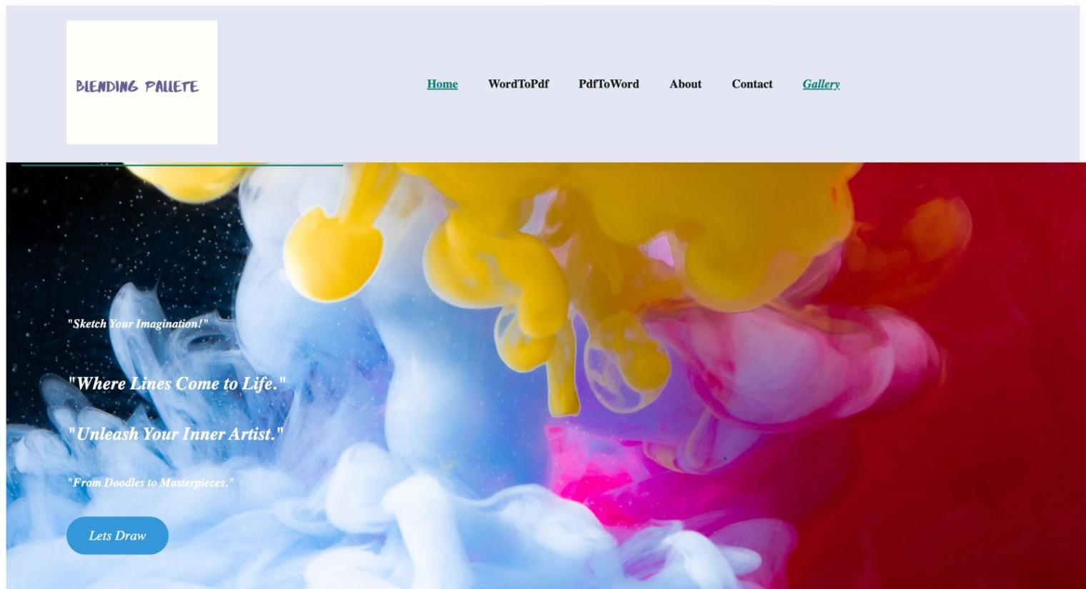 Figure 7.1 Blending Pallete Front page

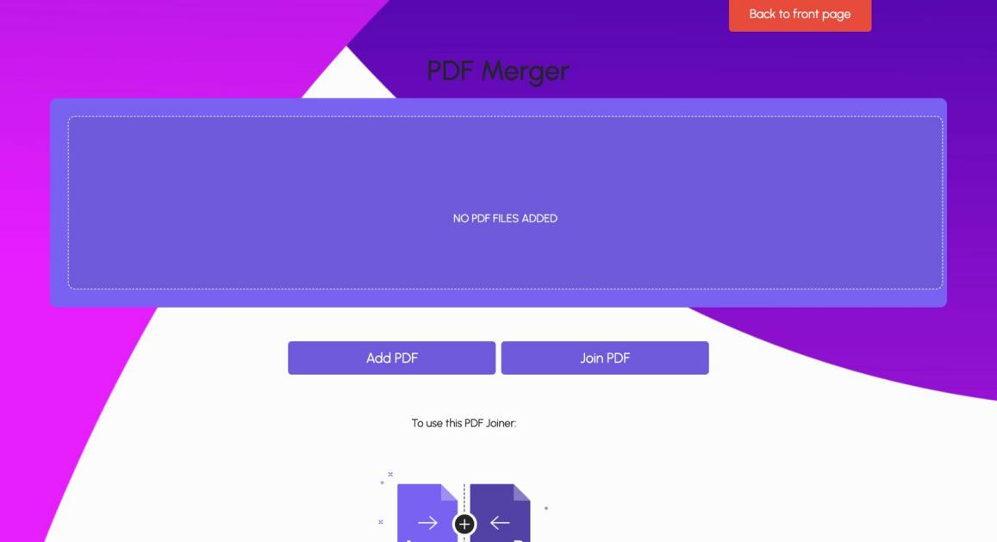Figure 7.2 Pdf merger

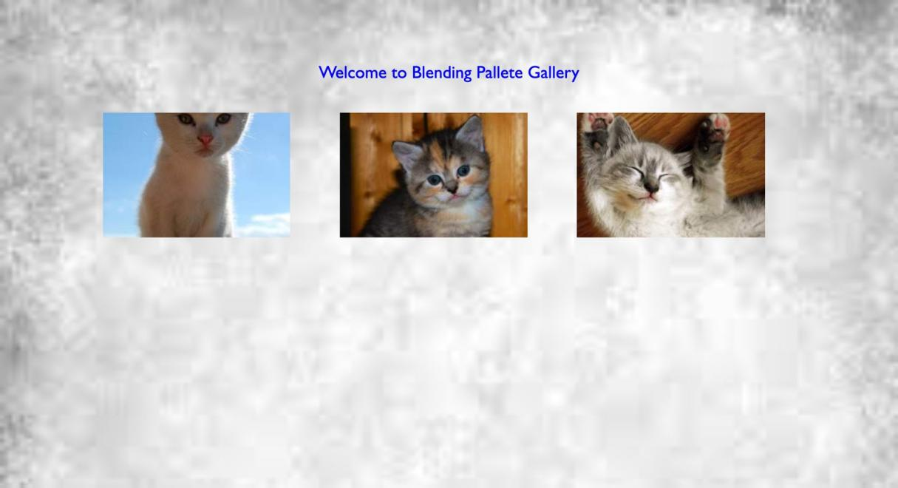

Figure 7.3 Blending Pallete Gallery

Figure 7.3 Blending pallete document to PDF Converter

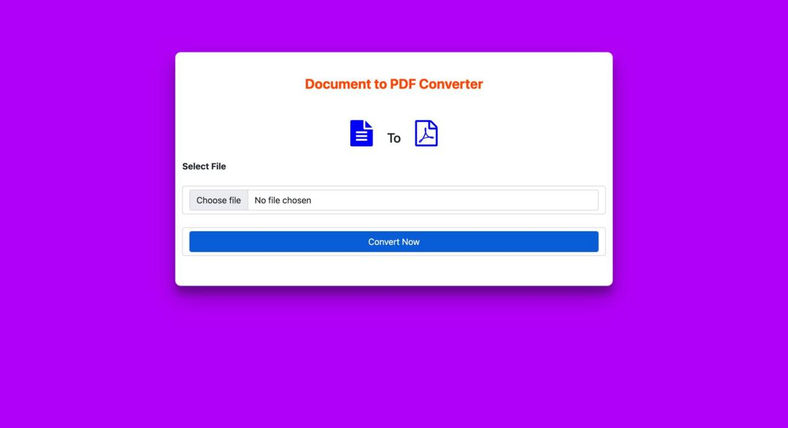

Group/Team no: G21/T22

Group/Team no: G21/T22

Figure 7.4 Blending pallete DOcx to pdf converter

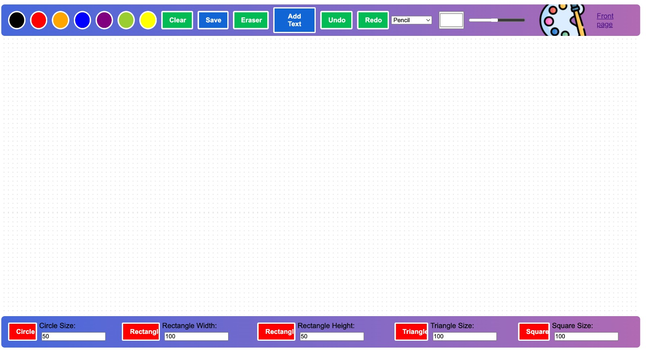

Figure 7.5 Blending pallete CANVAS

Conclusion

In conclusion, our drawing tool, known as the Blending Palette, is a dynamic gateway for users to express their creative visions and convey ideas through captivating visual representations. Whether in the form of software or a physical instrument, this tool empowers artists, designers, and creators across various domains.

The Blending Palette offers a multitude of features, including canvas drawing with customizable line thicknesses and colors, a versatile color palette, and an array of brush shapes, from pencils to spray paint. Users can effortlessly draw basic shapes, add text to their creations, and utilize the eraser for precise editing. Furthermore, the tool supports undo/redo functionalities, ensuring that no creative idea is lost. Saving drawings as PNG images is made simple, and the responsive design guarantees that users can unleash their creativity on any device. The user-friendly interface, coupled with customization options for line thickness and background color, enhances the personalization of artworks. As a bonus feature, we've integrated document conversion capabilities, allowing users to transform PDFs into editable Word documents and vice versa. This holistic approach distinguishes our tool, offeringa one-stop solution for both creative and document-related tasks. The Blending Palette is not just a drawing tool; it's a platform that transcends traditional boundaries, fostering artistic expression and practical utility in a harmonious blend of art and technology. In the ever-evolving digital landscape, our tool empowers users to explore endless creative possibilities while contributing to environmental sustainability through the reduction of paper consumption.

**References**

* https://youtube.com/
* <https://www.w3schools.com/>
* <https://www.geeksforgeeks.org/>
* https://en.wikipedia.org/wiki/
* https://images.google.com/
* https://www.programiz.com/
* <https://sketch.io/sketchpad/>
* <https://www.autodraw.com/>